**Data Management System for a University**

**Contents**

1. **Introduction …………………………………………………………….**
   1. Brief Overview of the Project ………………………………………
   2. Objectives and Goals ………………………………………………..
   3. Summary of Technologies and Methodologies Used ………
2. **Data Base Design ……………………………………………………..**
   1. Description of the Relational Database Schema ……………
   2. Entity-Relationship Diagram ………………………………………
   3. Explanation of Mapping Process and Importance ………….
   4. Overview of Tables ……………………………………………………
3. **SQL/PLSQL Implementation ………………………………………**
   1. SQL Scripts ……………………………………………………………..
   2. PLSQL Scripts ………………………………………………………….
4. **Automation Scripts …………………………………………………..**
   1. Database Backup Script ……………………………………………
   2. Disk Space Monitoring Script ……………………………………..
   3. System Anomaly Detection Script ……………………………….
5. **Java Application Development …………………………………..**
   1. Server Part ………………………………………………………………
   2. Client Part ……………………………………………………………….
6. **Introduction :**
   1. **Brief Overview of the Project:**

The University Data Management System is a comprehensive solution designed to streamline and optimize the management of student, doctors, course, department, and grade-related data within the university environment. It encompasses various components such as database design, SQL and PLSQL implementation, automation scripting, Java application development, and integration to ensure efficient data handling and reporting capabilities.

* 1. **Objectives and Goals:**
* Designing and implementing a robust relational database schema to store and manage student, doctors, course, department, grades, GPA history information securely.
* Developing SQL and PLSQL scripts to facilitate data manipulation tasks and perform complex calculations such as GPA computation.
* Implementing automation scripts to automate routine tasks like database backup, disk space monitoring, and anomaly detection for system reliability.
* Creating a Java application following OOP principles to interact with the database, enabling CRUD operations and seamless integration.
* Generating comprehensive reports within the Java application to provide valuable insights into courses, enrolled students, and average GPA per course.
  1. **Summary of Technologies and Methodologies Used:**
* Utilization of SQL for database schema creation and normalization to maintain data integrity.
* Implementation of SQL and PLSQL for data querying, manipulation, and procedural tasks.
* Development of Bash scripts for automating critical system maintenance tasks.
* Use of Java SE and OOP principles for building a robust application with efficient data handling capabilities.
* Seamless integration between the Java application and the SQL database to ensure smooth data flow and reporting.
* Adherence to software engineering best practices, including documentation, testing, and version control, for project quality and maintainability.

1. **Database Design :**
   1. **Description of the Relational Database Schema:**

The relational database schema for the university data management system comprises tables representing students, doctors, courses, departments, grades, and GPA history. Each table is designed to store specific information related to its corresponding entity, and relationships between tables are established using foreign key constraints.

* 1. **Entity-Relationship Diagram:**

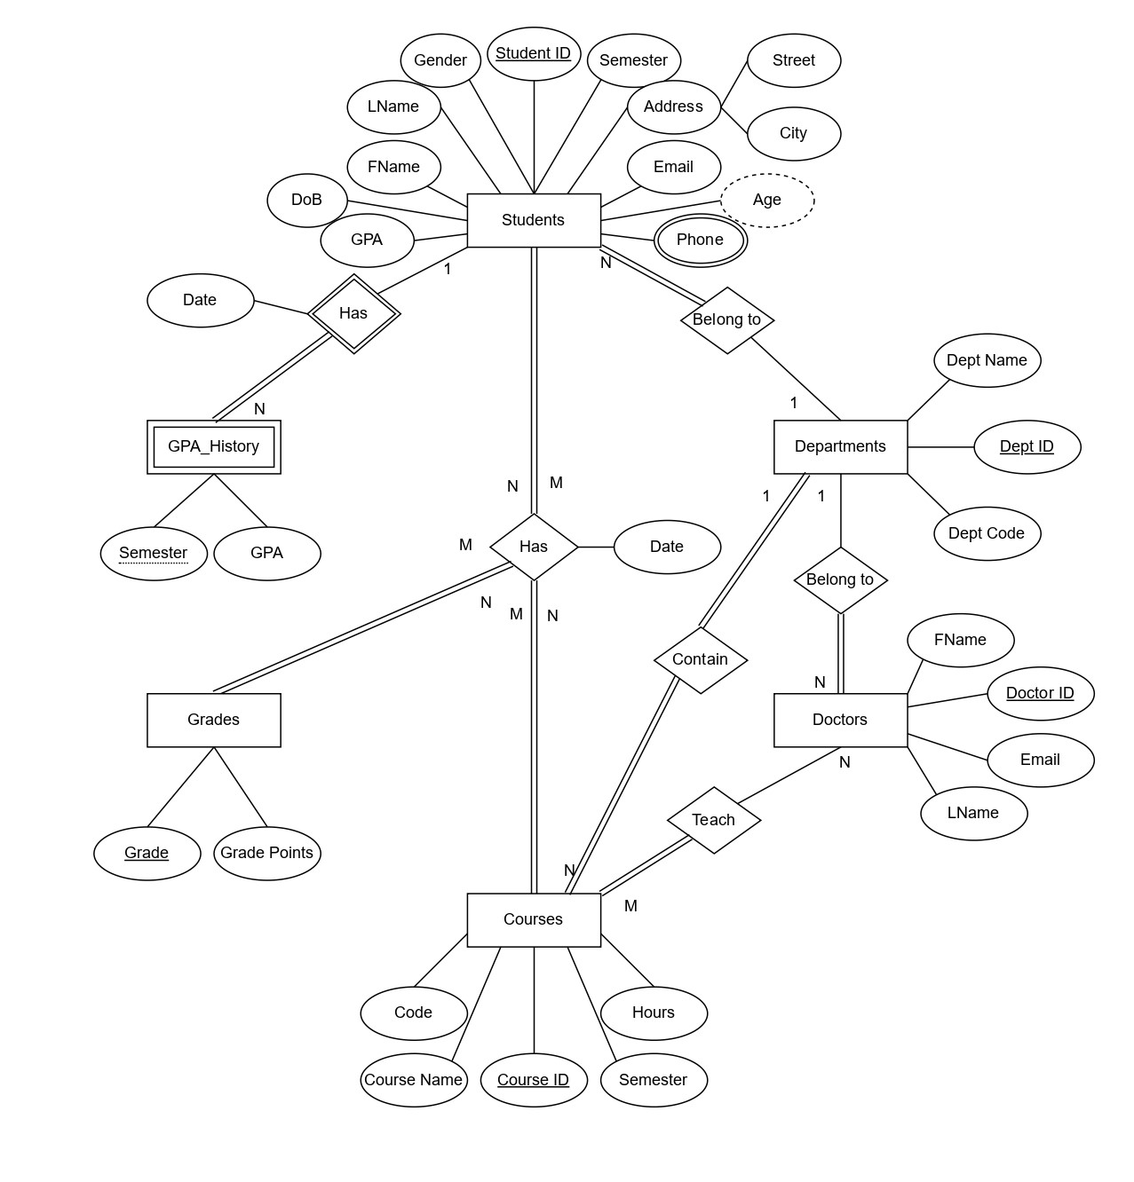

* 1. **Explanation of Mapping Process and Importance:**

Mapping is the process of translating real-world entities and relationships into a structured database schema. It involves identifying entities, their attributes, and relationships between them, which are then represented as tables, columns, and foreign key constraints in the database.

**In this schema:**

* + - The students table contains information about individual students, such as their ID, name, email, date of birth, gender, semester, GPA, address, and department ID. The student_ID serves as the primary key.
    - The student_Phone table stores phone numbers associated with each student, with the student_ID linking to the corresponding student record.
    - The Departments table holds department details, including department ID, name, and code. The Dept_ID serves as the primary key.
    - The Courses table stores information about courses offered, including course ID, name, hours, code, semester, and department ID. The Course_ID serves as the primary key, and the Dept_ID is a foreign key referencing the department table.
    - The Doctors table contains information about course instructors, including Doctor ID, name, email, and department ID. The Doctor_ID serves as the primary key, and the Dept_ID is a foreign key linking to the department table.
    - The Teach table establishes the many-to-many relationship between doctors and courses, with Doctor_ID and Course_ID serving as composite primary keys and foreign keys referencing the respective tables.
    - The Grades table stores grade information, including grade and grade points.
    - The Has table represents the many-to-many relationship between students and courses, storing student ID, course ID, grade, and date. Both student ID and course ID are foreign keys linking to their respective tables.
    - The GPA_History table maintains historical GPA records for students, including student ID, semester, GPA, and date.
  1. **Overview of Tables:**

**Students :**

(Student_ID, FName, LName, Email, DoB, Gender, Semester, GPA, City, Street, Dept_ID(FK))

**Student_Phone :**

(Student_ID(FK), Phone)

**Departments :**

(Dept_ID, Dept_Name, Dept_Code)

**Courses :**

(Course_ID, Course_Name, Hours, Course_Code, Semester, Dept_ID(FK))

**Doctors :**

(Doctor_ID, FName, LName, Email, Dept_ID(FK))

**Teach :**

(Doctor_ID(FK), Course_ID(FK))

**Grades :**

(Grade, Grade Points)

**Has :**

(Student_ID(FK), Course_ID(FK), Grade(FK), Date)

**GPA_History** **:**

(Student_ID(FK), Semester, GPA, Date)

1. **SQL/PLSQL Implementation :**
   1. **SQL Scripts :**
      * **Creation Script :**

This is a Script that is used to create all my tables including Students, Doctors, Courses, Departments, Teach, Has, Grades, GPA_History.

* + - **Test Data Script :**

This is a script that is used to insert samples data into database.

* 1. **PLSQL Scripts :**

Which is divided into sequences, functions, procedures, and triggers Scripts

**Sequences :**

* + - * **Sequence Script :**

This is a Script used to create a sequences for Students, Doctors, Courses, Departments tables.

**Functions :**

* **Get_IDs Script :** This script have 4 functions that are used to get the id of student, doctor, course, or department.
* **calc_course_avg_gpa Script :** This script is used to calculate the Average grades or gpa of the course for all students that enrolled in this course.
* **calc_gpa Script :** This script is used to calculate the CGPA of the student.

**Procedures :**

* + - * **insert_student_info Script :** This Script used to insert the students information except phones information into students table.
      * **insert_student_phones Script :** This Script used to insert the student’s phones information into student_phones table.
      * **insert_doctor_info Script :** This Script used to insert the doctors information into doctors table.
      * **insert_course_info Script :** This Script used to insert the courses information into courses table.
      * **insert_department_info Script :** This Script used to insert the departments information into departments table.
      * **insert_take Script :** This Script used to insert the student id, course id, and date into has table.
      * **Insert_has Script :** This Script used to update the grade of the student to a specific course into has table.
      * **Insert_teach Script :** This Script used to insert the doctor_id, and course_id into teach table.
      * **Upd_student_info Script :** This Script used to update the student informations.
      * **Upd_course_info Script :** This Script used to update the course informations.
      * **delete_student Script :** This Script used to delete the students information from students table and all other tables that have data related to that student.
      * **delete_doctor Script :** This Script used to delete the doctors information from doctors table and all other tables that have data related to that doctor.
      * **delete_course Script :** This Script used to delete the courses information from courses table and all other tables that have data related to that course.
      * **delete_teach Script :** This Script used to delete the doctor_id and course_id from teach table.
      * **delete_department Script :** This Script used to delete the departments information from departments table if there is no related data with this department and any other tables.

**Triggers :**

* + - * **insert_gpa_history Script :** This Script used to add student_id, semester, grade, and date into gpa_history table when the information of student updated and move to next semester.

1. **Automation Bash Scripts :**

These are bash scripts used to automate some tasks like backup the database, Disk space monitoring, and a scheduling system anomaly detection script.

* 1. **Database Backup Bash Script:**

**Purpose and Functionality:** This bash script is designed to perform a database backup using the expdp utility. It generates a unique name for the backup file based on the current date and time. After the backup operation, it checks the exit status of the command. If the backup is successful (exit status 0), it appends "Backup Success" to the log file; otherwise, it appends "Backup Failed" to the log file.

* 1. **Disk Space Monitoring Bash Script:**

**Purpose and Functionality:** This bash script monitors disk space usage on the system. It sets a threshold value (in percentage) for disk usage. It retrieves the current disk usage percentage and compares it with the threshold value. If the usage exceeds the threshold, it appends a warning message to the log file indicating that disk usage is above average.

* 1. **System Anomaly Detection Bash Script:**

**Purpose and Functionality:** This bash script detects anomalies related to CPU usage, RAM usage, and disk space availability on the system.

* + - * It checks the CPU load percentage and compares it with a predefined threshold. If the CPU usage exceeds the threshold, it appends a warning message to the log file.
      * It calculates the available RAM percentage and compares it with a predefined threshold. If the RAM usage exceeds the threshold, it appends a warning message to the log file.
      * It calculates the available disk space percentage and compares it with a predefined threshold. If the disk usage exceeds the threshold, it appends a warning message to the log file.

This script is scheduled to run daily at 1 PM using task scheduler.

1. **Java Application Development :**

The Java application development is divided into 2 parts. Server part and Client part

**Server consist of 3 main parts:**

1. **GUI :**

It has simple gui with only 2 buttons start and stop, to start the server and stop it

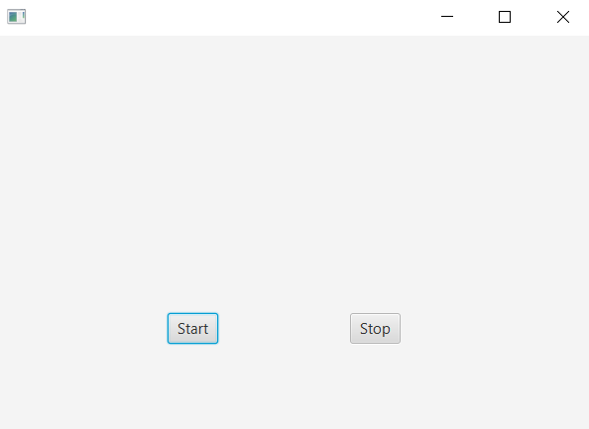

1. **Main thread class :**

which listen to coming connections from clients on a specific port then it takes the json file that was sent by the client and deserialize it then from its 2 parts key and value. It use the key to enter the condition and then pass the value to the DAO calss

1. **DTO and DAO classes :**
2. **DTO classes :**

Dto classes is classes created for each entity in my database (Students, Doctors, Course, Departments, Has, StudentPhones), they carry inside them the information that the client want to send to the server.

1. **DAO class :**

It is responsible for interacting with a database. It has many functions each one

Connect to database then call functions or procedures.

**Methods**:

* + **addStudent**: Inserts a new student record into the database.
  + **addStudentPhones**: Inserts a new phone number for a student into the database.
  + **addDoctor**: Inserts a new doctor record into the database.
  + **addCourse**: Inserts a new course record into the database.
  + **addDepartment**: Inserts a new department record into the database.
  + **deleteStudent**, **deleteDoctor**, **deleteCourse**, **deleteDepartment**: Deletes records from the corresponding tables.
  + **updateStudent**, **updateCourse**: Updates student and course records.
  + **addTake**, **addHas**, **addTeach**, **deleteTeach**: Inserts or deletes records related to student-course, course-grade, and teacher-course associations.
  + **getCGPA**: Retrieves the Cumulative Grade Point Average (CGPA) for a student.
  + **getSemesterGPA**: Retrieves the GPA for a specific semester of a student.
  + **showSemesterCourses**, **showStudentCourses**, **showDoctorNotCourses**, **showCourses**, **showDoctorCourses**, **showStudents**: Fetches various data from the database such as courses, students, etc.
  + **getCourseAVG_GPA**: Calculates the average GPA for a course.
  + **selectDepartmentCode**, **selectStudentID**, **selectDoctorID**, **selectCourseID**, **selectDepartmentID**: Helper methods to retrieve IDs or codes from the database.

**Exception Handling**: Each method handles **SQLException** by returning appropriate values.

**Client consist of 3 main parts:**

1. **GUI (FXML files with its java base classes) :**

**Login Scene :**

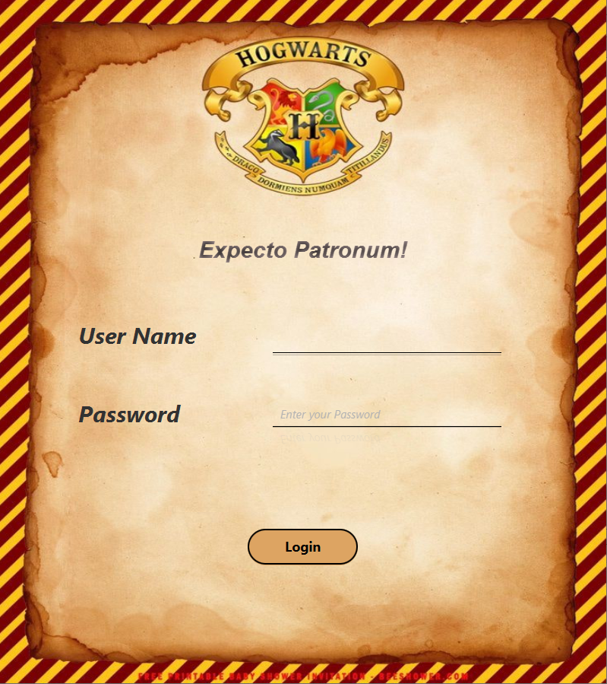

1. **Students Scenes:**

**Main Scene (Insert) :**

This is main scene where you can insert information about students, also it have the buttons to move to other main scenes or any scene related to students.

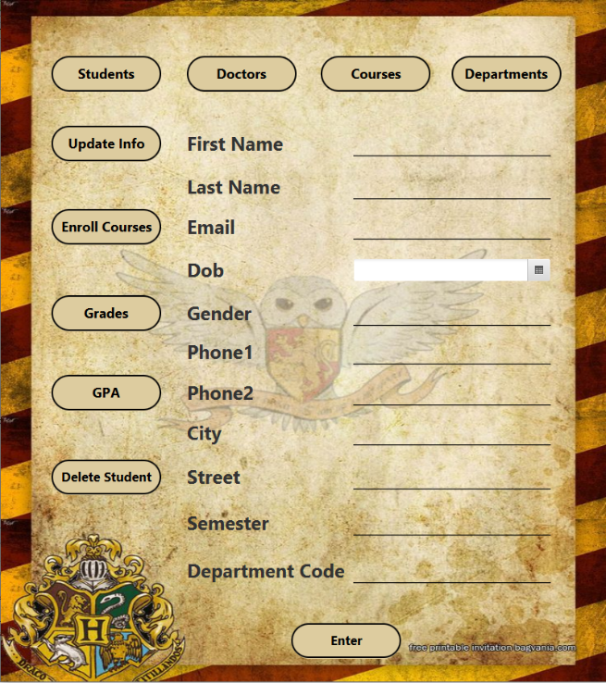

**Update Student Scene :**

In This Scene you can update students information like city, street, phone numbers, and semester if he moves to the next semester.

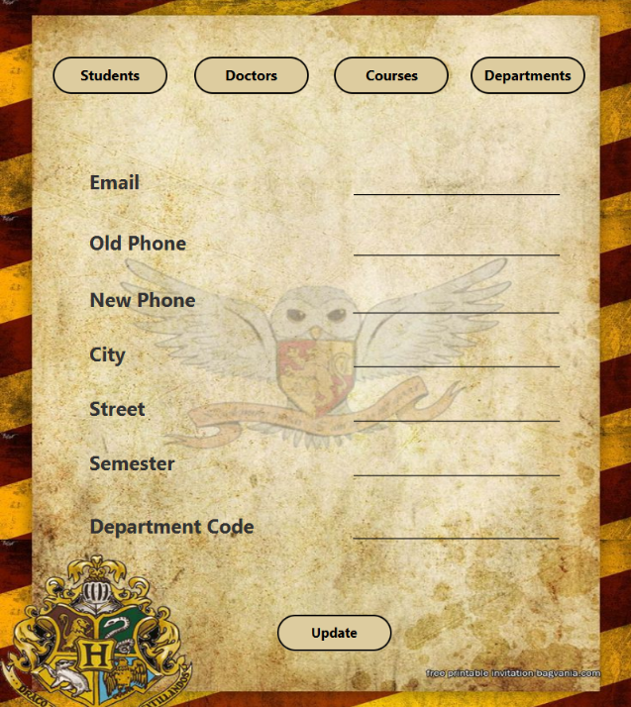

**Enrollment Scene :**

In this scene students can enroll there courses they want to take related to their semester.

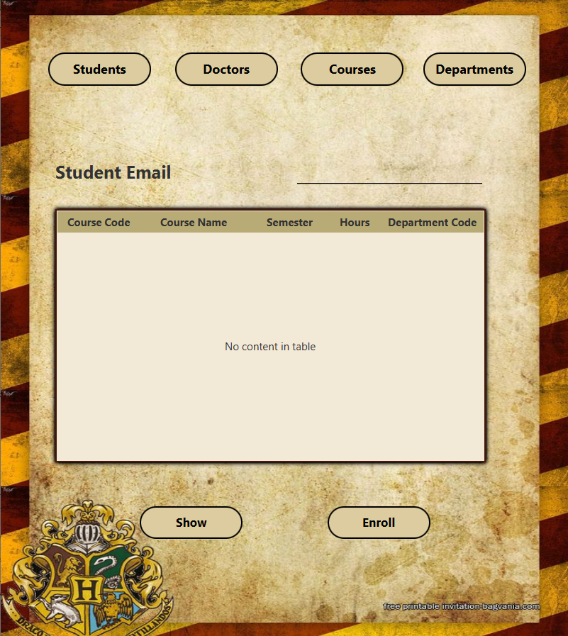

**Course GPA Scene :**

In this Scene the grades of the student in his selected courses will be add

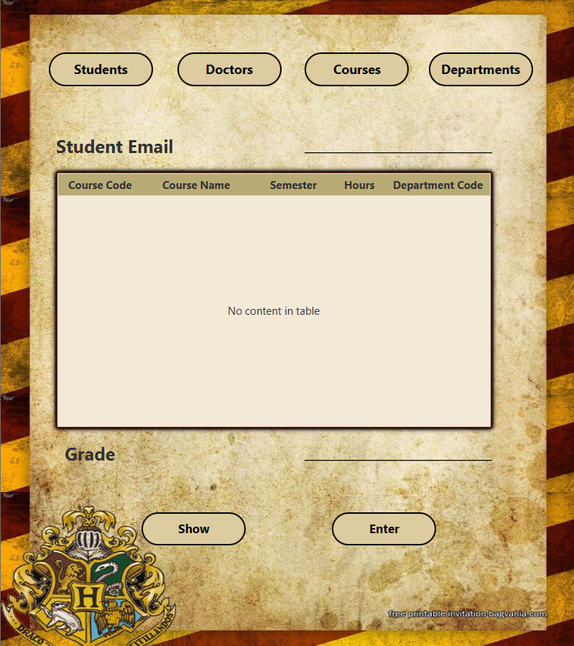

**GPA Scene :**

In this scene the student can know his CGPA, or he can enter semester and choose to see his GPA for a specific semester.

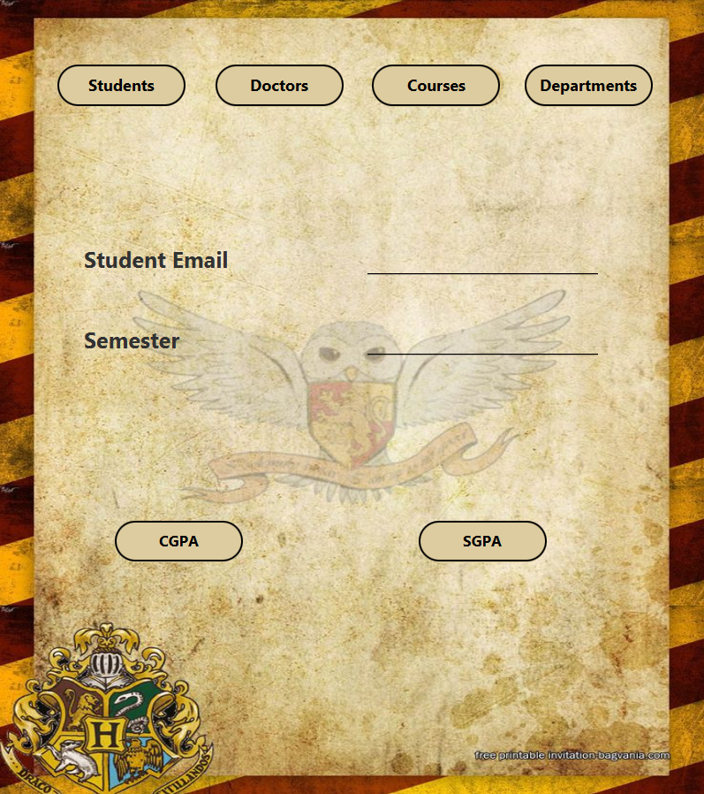

**Delete Student Scene :**

In this scene you can enter the student email and delete this student with his all related data.

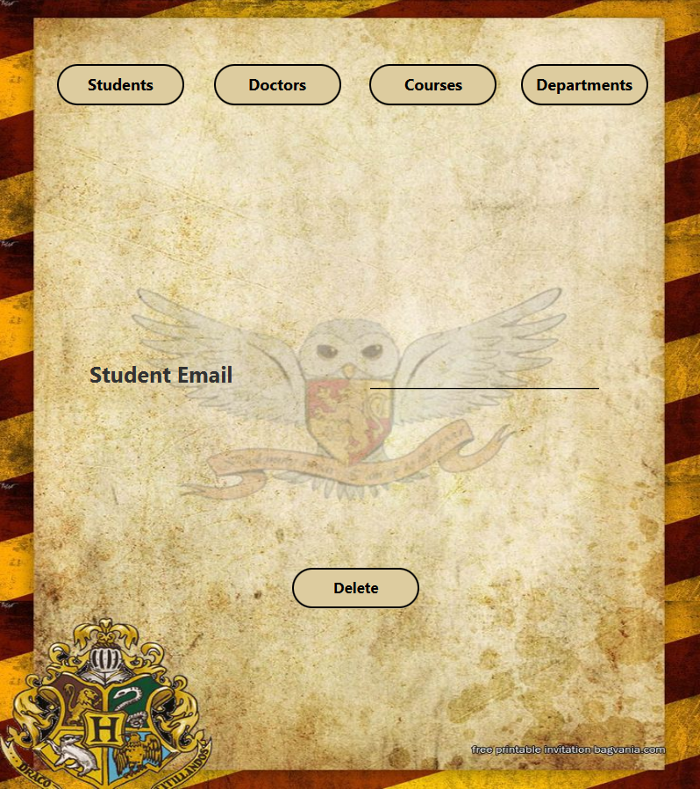

1. **Doctors Scenes:**

**Main Scene (Insert) :**

In this scene the information of doctor can be inserted also it has the 4 main button to move to other main scenes, and buttons to move to scenes related to doctors.

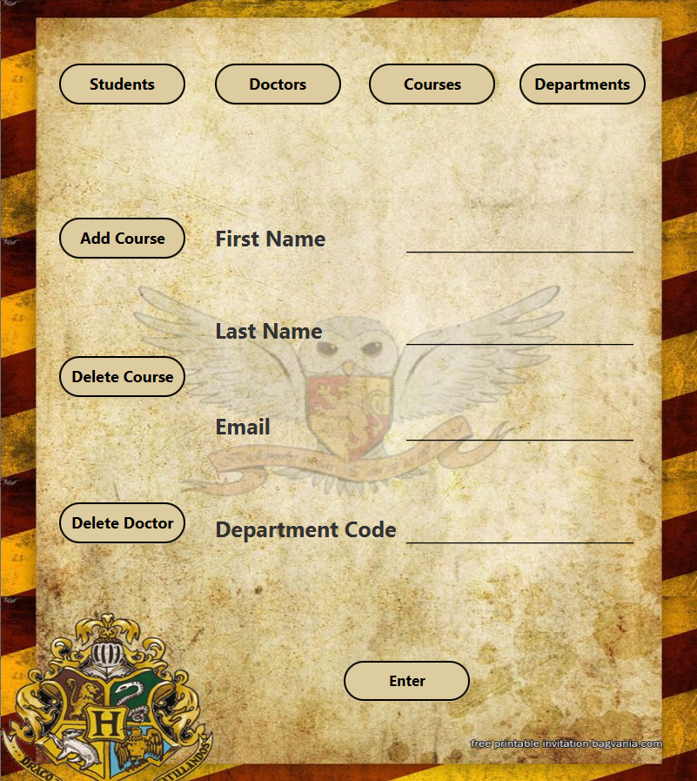

**Add Course Scene :**

In this scene the information of what courses that doctor want to teach inserted, and must be courses belong to his department.

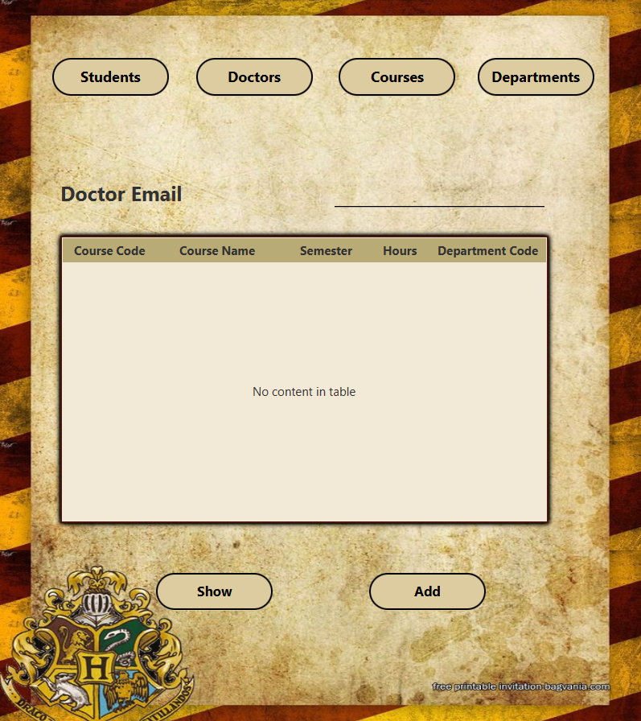

**Delete Course Scene :**

In this scene you can remove the assigned courses from doctor.

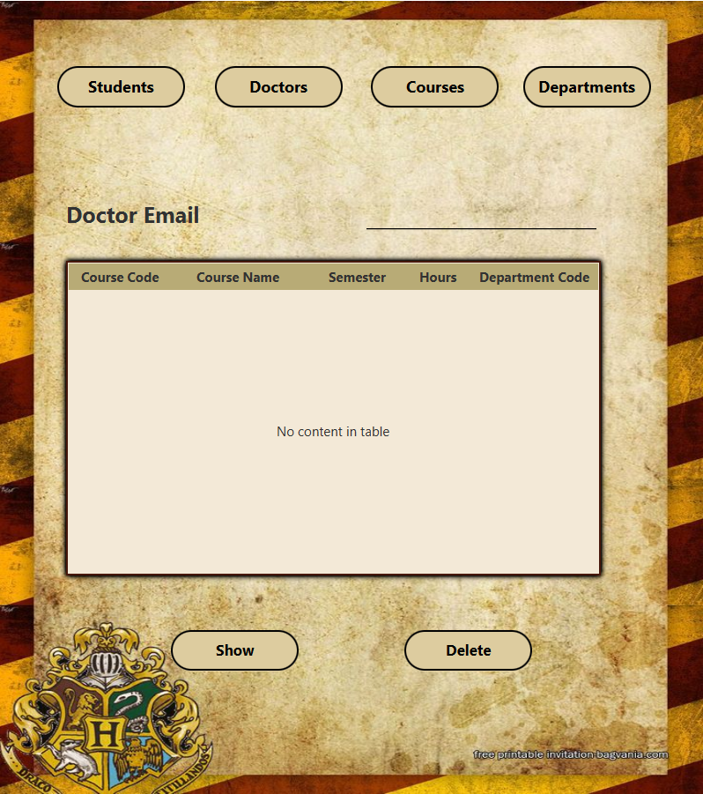

**Delete Doctor Scene :**

In this scene you can delete a doctor with all of its related data.

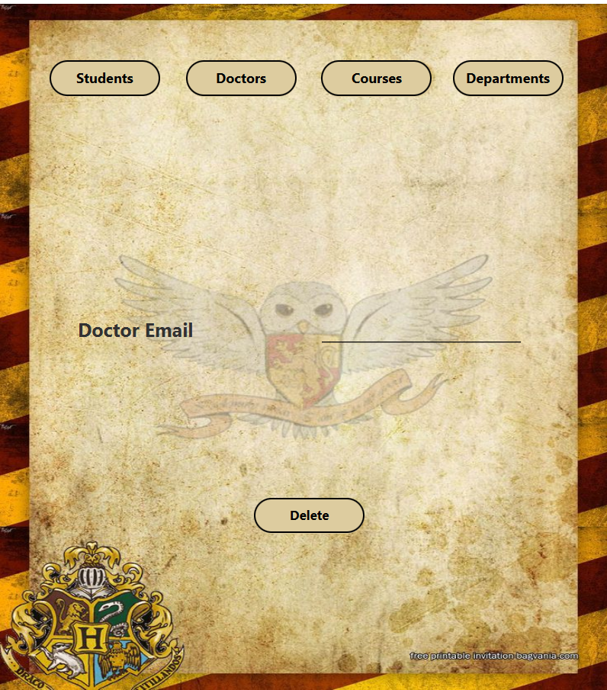

1. **Course Scenes :**

**Main Scene (Insert) :**

In this scene the information of course can be inserted also it has the 4 main buttons to move to other main scenes and buttons to move to scenes related to courses.

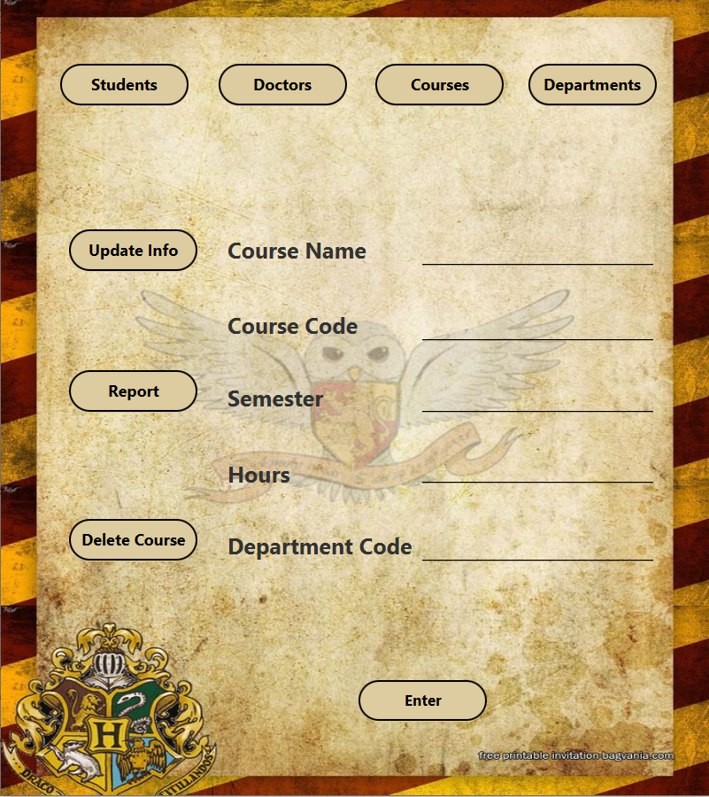

**Update Course Scene :**

In This Scene you can update courses information like semester, hours and department code

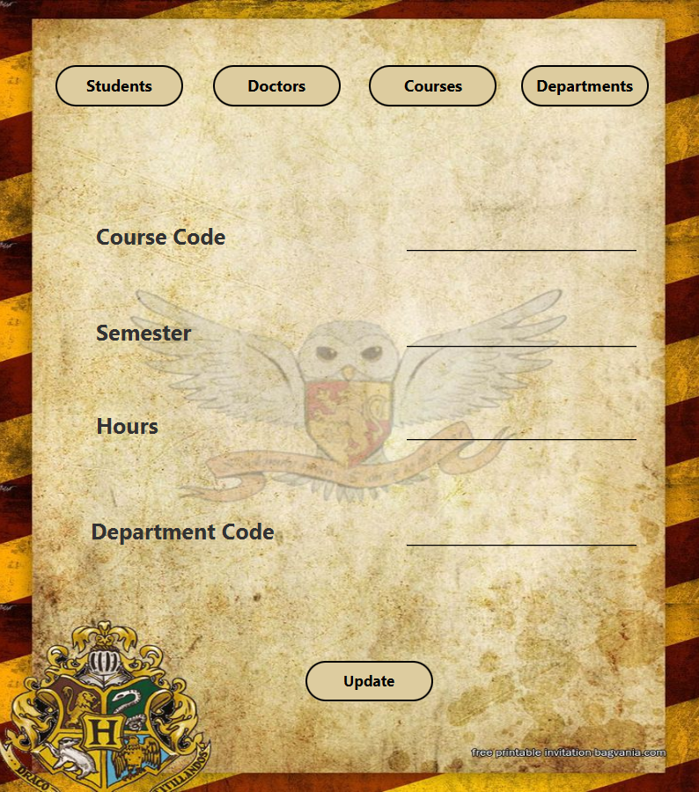

**Report Scene :**

In this Scene you can show the courses exist and choose one to see the enrollment students in this scene with all of their information also you can see the Average GPA of this course.

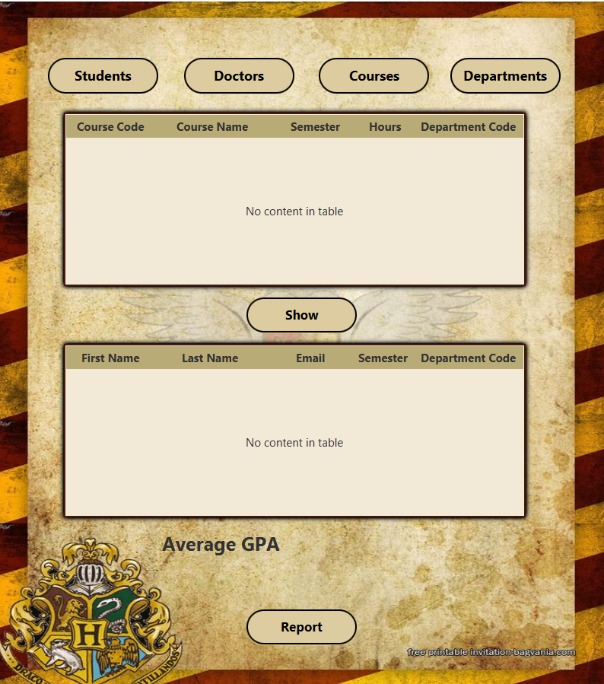

**Delete Scene :**

In this scene you can delete a course with all of its related data.

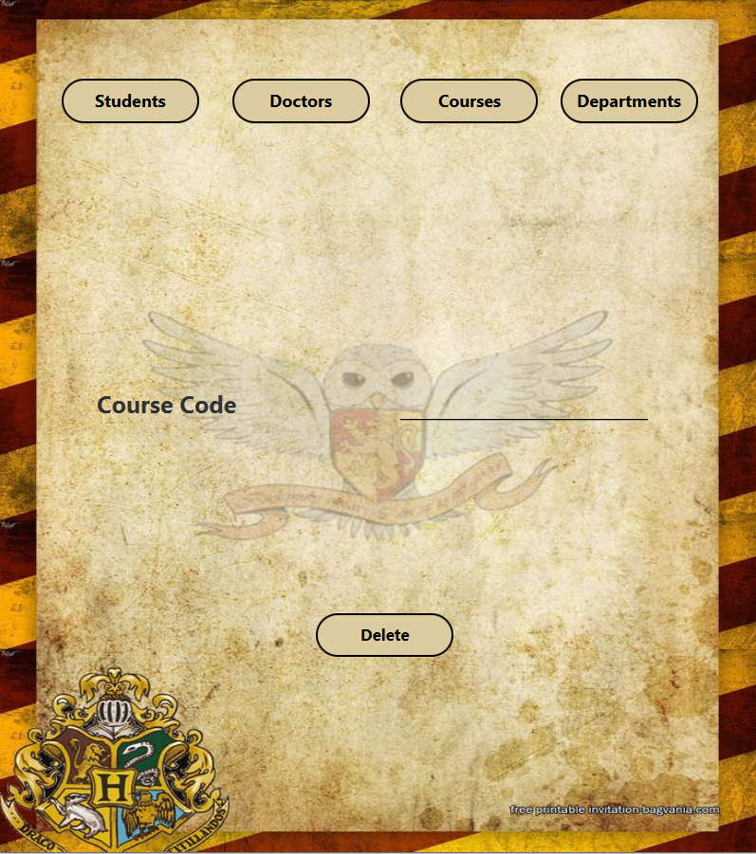

1. **Departments Scenes :**

**Main Scene (Insert) :**

In this scene you can a department, also it has the 4 main buttons to move to other main scenes and buttons to move to scenes related to department.

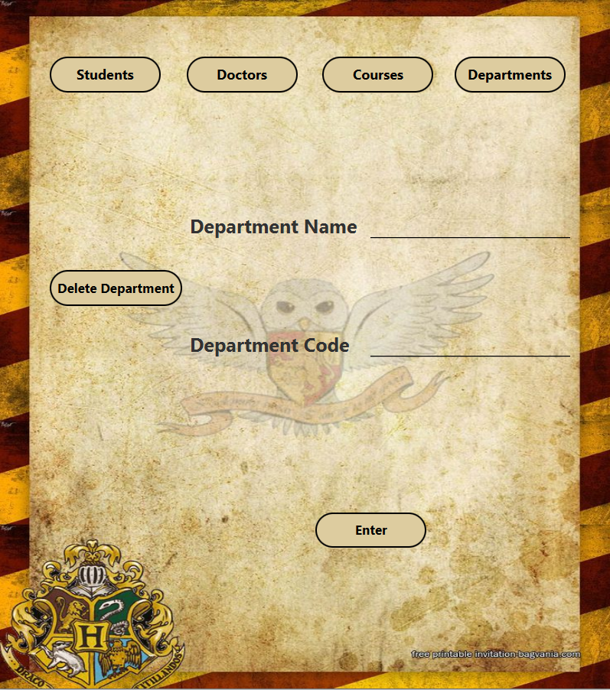

Delete Scene :

In this scene you can delete a department only when there is no students, doctors or courses assigned to it.

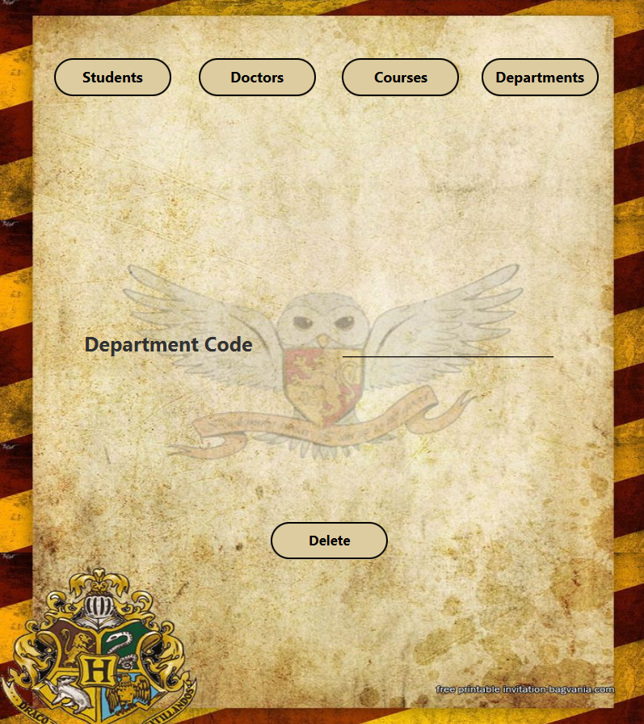

1. **DTO Classes :**

Dto classes is classes created for each entity in my database (Students, Doctors, Course, Departments, Has, StudentPhones), they carry inside them the information that the client want to send to the server.

1. **Controllers :**
2. **Login Controller :**

It just have 1 button which is the login button it take the user name and password from the user using text fields then serialize it using json and send it to the server. The server will replay with 0 or 1 which indicates successful or failed login attempt. If it is a failed attempt error message will be shown on the screen indicates that username or password is invalid, and if it a successful attempt the scene will be switched to the students main scene.

1. **Students Controller :**

**Adding Students:**

Upon clicking the "Enter" button, the controller establishes a connection with the server and sends student data in JSON format.

It handles server responses to display success or error messages using JavaFX alerts.

**Navigation:**

Provides navigation to different scenes within the application using buttons like "Students," "Doctors," "Courses," etc.

Each button click triggers a scene switch managed by the SceneController class.

**Exception Handling:**

Catches and logs exceptions using Java's logging framework (java.util.logging).

Displays error messages in the UI to notify users of any issues encountered during data processing or network communication.

1. **UpdateStudent Controller :**

**Updating Student Records:**

Upon clicking the "Update" button, the controller establishes a connection with the server and sends updated student data.

It handles server responses to display success or error messages using JavaFX alerts.

**Navigation:**

Provides navigation to different scenes within the application using buttons like "Students," "Doctors," "Courses," etc.

Each button click triggers a scene switch managed by the SceneController class.

**Exception Handling:**

Catches and logs exceptions using Java's logging framework (java.util.logging).

Displays error messages in the UI to notify users of any issues encountered during data processing or network communication.

1. **Enrollment Controller :**

**Enrollment Process:**

Upon clicking the "Show" button the controller establishes a connection with the server and show the courses that student can enroll with his semester then when he press "Enroll" button, the controller establishes a connection with the server and insert into has table the that this student take that course.

It handles server responses to display success or error messages using JavaFX alerts.

**Navigation:**

Provides navigation to different scenes within the application using buttons like "Students," "Doctors," "Courses," etc.

Each button click triggers a scene switch managed by the SceneController class.

**Exception Handling:**

Catches and logs exceptions using Java's logging framework (java.util.logging).

Displays error messages in the UI to notify users of any issues encountered during data processing or network communication.

1. **Course GPA Controller :**

**Grade Entry Process:**

Upon clicking the "Enter" button, the controller establishes a connection with the server and sends the entered grade for the selected course after it appear in the table view using the "Show" button.

It calculates the grade based on the entered grade points and sends the data to the server.

**Navigation:**

Provides navigation to different scenes within the application using buttons like "Students," "Doctors," "Courses," etc.

Each button click triggers a scene switch managed by the SceneController class.

**Exception Handling:**

Catches and logs exceptions using Java's logging framework (java.util.logging).

Displays error messages in the UI to notify users of any issues encountered during data processing or network communication.

1. **GPA Controller :**

**CGPA Calculation Process:**

Upon clicking the "Calculate CGPA" button, the controller establishes a connection with the server and sends a request to calculate the CGPA for the specified student.

The server processes the request using the calc_gpa function and sends back the calculated CGPA, which is then displayed in the UI.

**SGPA Calculation Process:**

Clicking the "Calculate SGPA" button triggers a similar process to calculate the Semester GPA for the specified student.

The server get the data from the gpa history table and then sends it back to the client for display.

**Navigation:**

Provides navigation to different scenes within the application using buttons like "Students," "Doctors," "Courses," etc.

Each button click triggers a scene switch managed by the SceneController class.

**Error Handling:**

If invalid data is entered or an error occurs during the GPA calculation process, appropriate error messages are displayed in the UI to notify the user.

1. **Delete Student Controller :**

**Deletion Process:**

Upon clicking the "Delete" button, the controller displays a warning message to confirm deletion of student data.

If the user confirms deletion, the controller establishes a connection with the server, sends a deletion request, and waits for a response.

The server processes the deletion request and sends back a response indicating the success or failure of the operation.

The UI is updated accordingly to display success or error messages.

**Error Handling:**

Handles scenarios such as non-existent student data or server communication issues by displaying appropriate error messages to the user.

**Navigation:**

Provides navigation to different scenes within the application using buttons like "Students," "Doctors," "Courses," etc.

Each button click triggers a scene switch managed by the SceneController class.

1. **Doctors Controller :**

**Doctor Addition:**

Upon clicking the "Enter" button, the controller establishes a connection with the server and sends doctor details for addition.

Upon receiving a response from the server, the UI is updated with success or error messages indicating the result of the addition process.

**Navigation:**

Provides navigation to different scenes within the application using buttons like "Students," "Courses," "Departments," etc.

Additionally, provides functionality to switch to scenes for adding doctor courses, deleting doctor courses, and deleting doctors.

**Error Handling:**

Handles scenarios such as existing doctor data or server communication issues by displaying appropriate error messages to the user.

1. **Add Doctor Course Controller :**

**Course Display:**

Upon clicking the "Show" button, the controller retrieves available courses for doctors from the server and displays them in a table view for selection.

**Course Addition:**

Upon clicking the "Add" button, the controller establishes a connection with the server, sends doctor and selected course details for addition.

Upon receiving a response from the server, the UI is updated with success or error messages indicating the result of the addition process.

**Navigation:**

Provides navigation to different scenes within the application using buttons like "Students," "Doctors," "Courses," "Departments," etc.

**Error Handling:**

Handles scenarios such as existing course data or server communication issues by displaying appropriate error messages to the user.

1. **Delete Doctor Course Controller :**

**Course Display:**

Upon clicking the "Show" button, the controller retrieves assigned courses for doctors from the server and displays them in a table view for selection.

**Course Deletion:**

Upon clicking the "Delete" button, the controller establishes a connection with the server, sends doctor and selected course details for deletion.

Upon receiving a response from the server, the UI is updated with success or error messages indicating the result of the deletion process.

**Navigation:**

Provides navigation to different scenes within the application using buttons like "Students," "Doctors," "Courses," "Departments," etc.

**Error Handling:**

Handles scenarios such as server communication issues by displaying appropriate error messages to the user.

1. **Delete Doctor Controller :**

**Doctor Deletion:**

Upon clicking the "Delete" button, the controller displays a warning message to the user indicating that all data related to the doctor will be deleted.

Upon user confirmation, the controller establishes a connection with the server, sends doctor details for deletion.

Upon receiving a response from the server, the UI is updated with success or error messages indicating the result of the deletion process.

**Navigation:**

Provides navigation to different scenes within the application using buttons like "Students," "Doctors," "Courses," "Departments," etc.

**Error Handling:**

Handles scenarios such as server communication issues by displaying appropriate error messages to the user.

1. **Course Controller :**

**Course Addition:**

Upon clicking the "Enter" button, the controller establishes a connection with the server.

Sends course details entered by the user to the server for addition to the database.

Upon receiving a response from the server, updates the UI with success or error messages indicating the result of the addition process.

**Navigation:**

Provides navigation to different scenes within the application using buttons like "Students," "Doctors," "Courses," "Departments," etc.

Allows navigation to specific scenes like updating courses and generating reports.

**Error Handling:**

Handles scenarios such as server communication issues by displaying appropriate error messages to the user.

1. **Update Course Controller :**

**Course Update:**

Upon clicking the "Update" button, the controller establishes a connection with the server.

Sends updated course details entered by the user to the server for updating in the database.

Upon receiving a response from the server, updates the UI with success or error messages indicating the result of the update process.

**Navigation:**

Provides navigation to different scenes within the application using buttons like "Students," "Doctors," "Courses," "Departments," etc.

**Error Handling:**

Handles scenarios such as server communication issues by displaying appropriate error messages to the user.

Provides error messages if invalid data is entered for course update.

1. **Report Controller :**

**Report Generation:**

Allows users to select a specific course from table view after pressing on "show" button and upon selecting a course and clicking the "Generate Report" button, sends a request to the server for student data associated with the selected course.

Displays student data in the UI, along with calculated GPA information, if available.

**Navigation:**

Provides navigation to different scenes within the application using buttons like "Students," "Doctors," "Courses," "Departments," etc.

**Error Handling:**

Handles scenarios such as server communication issues by displaying appropriate error messages to the user.

Provides error messages if there is an issue with retrieving or displaying report data.

1. **Delete Course Controller :**

**Course Deletion:**

Upon clicking the "Delete" button, the controller establishes a connection with the server and prompts the user with a warning message about the consequences of course deletion.

Upon user confirmation, sends a request to the server to delete the specified course.

Updates the UI with success or error messages based on the server response.

**Navigation:**

Provides navigation to different scenes within the application using buttons like "Students," "Doctors," "Courses," "Departments," etc.

**Error Handling:**

Handles scenarios such as server communication issues by displaying appropriate error messages to the user.

Provides error messages if there is an issue with deleting the course.

1. **Departments Controller :**

**Department Addition:**

Upon clicking the "Enter" button, the controller establishes a connection with the server and sends a request to add a new department.

Updates the UI with success or error messages based on the server response.

**Navigation:**

Provides navigation to different scenes within the application using buttons like "Students," "Doctors," "Courses," "Departments," etc.

Includes a button for navigating to the delete department scene.

**Error Handling:**

Handles scenarios such as server communication issues by displaying appropriate error messages to the user.

Provides an error message if the department already exists in the system.

1. **Delete Department Controller :**

**Department Deletion:**

Upon clicking the "Delete" button, the controller establishes a connection with the server and sends a request to delete a department.

Updates the UI with success or error messages based on the server response.

Displays a message if the department does not exist or if there are associated data that need to be deleted first.

**Navigation:**

Provides navigation to different scenes within the application using buttons like "Students," "Doctors," "Courses," "Departments," etc.

**Error Handling:**

Handles scenarios such as server communication issues by displaying appropriate error messages to the user.

Provides error messages if the department does not exist or if there are associated data that need to be deleted first.